

S.PREETHAM CHANDRAN
CH.SC.U4CSE24113
Week – 7 Date - 19/02/2026
Design and Analysis of Algorithm(23CSE211)

1. Huffman Coding

Code:
//CH.SC.U4CSE24139
#include <stdio.h> #include <stdlib.h> #include <string.h> #define MAX_TREE_HT 100
#define MAX_CHAR 256 struct MinHeapNode {
char data; unsigned freq;
struct MinHeapNode *left, *right;
};
struct MinHeap { unsigned size; unsigned capacity;
struct MinHeapNode** array;
};
struct MinHeapNode* newNode(char data, unsigned freq) {
struct MinHeapNode* temp = (struct MinHeapNode*)malloc(sizeof(struct MinHeapNode));
temp->left = temp->right = NULL; temp->data = data;
temp->freq = freq; return temp;
}
struct MinHeap* createMinHeap(unsigned capacity) {
struct MinHeap* minHeap = (struct MinHeap*)malloc(sizeof(struct MinHeap)); minHeap->size = 0;
minHeap->capacity = capacity;
minHeap->array = (struct MinHeapNode**)malloc(minHeap->capacity * sizeof(struct MinHeapNode*));
return minHeap;
}
void swapMinHeapNode(struct MinHeapNode** a, struct MinHeapNode** b) { struct MinHeapNode* t = *a;
*a = *b;
*b = t;
}
void minHeapify(struct MinHeap* minHeap, int idx) { int smallest = idx;
int left = 2 * idx + 1; int right = 2 * idx + 2;

if (left < minHeap->size && minHeap->array[left]->freq < minHeap-
>array[smallest]->freq)
smallest = left;

if (right < minHeap->size && minHeap->array[right]->freq < minHeap-
>array[smallest]->freq)
smallest = right; if (smallest != idx) {
swapMinHeapNode(&minHeap->array[smallest], &minHeap->array[idx]); minHeapify(minHeap, smallest);
}
}
struct MinHeapNode* extractMin(struct MinHeap* minHeap) { struct MinHeapNode* temp = minHeap->array[0];
minHeap->array[0] = minHeap->array[minHeap->size - 1];
--minHeap->size; minHeapify(minHeap, 0); return temp;
}
void insertMinHeap(struct MinHeap* minHeap, struct MinHeapNode* minHeapNode) {
++minHeap->size;
int i = minHeap->size - 1;
while (i && minHeapNode->freq < minHeap->array[(i - 1) / 2]->freq) { minHeap->array[i] = minHeap->array[(i - 1) / 2];
i = (i - 1) / 2;
}
minHeap->array[i] = minHeapNode;
}
void buildMinHeap(struct MinHeap* minHeap) { int n = minHeap->size - 1;
for (int i = (n - 1) / 2; i >= 0; --i) minHeapify(minHeap, i);
}
int isLeaf(struct MinHeapNode* root) { return !(root->left) && !(root->right);
}
void printCodes(struct MinHeapNode* root, int arr[], int top) { if (root->left) {
arr[top] = 0;
printCodes(root->left, arr, top + 1);
}
if (root->right) { arr[top] = 1;
printCodes(root->right, arr, top + 1);
}
if (isLeaf(root)) {
printf(" %c | %3d | ", root->data, root->freq); for (int i = 0; i < top; ++i)
printf("%d", arr[i]); printf("\n");
}
}
void calculateSpaceSaving(struct MinHeapNode* root, int arr[], int top, int* totalOriginalBits, int* totalCompressedBits) {
if (root->left) { arr[top] = 0;
calculateSpaceSaving(root->left, arr, top + 1, totalOriginalBits, totalCompressedBits);
}
if (root->right) { arr[top] = 1;
calculateSpaceSaving(root->right, arr, top + 1, totalOriginalBits, totalCompressedBits);
}
if (isLeaf(root)) {
*totalOriginalBits += root->freq * 8; // Assuming 8 bits per character
*totalCompressedBits += root->freq * top;
}
}
void HuffmanCodes(char data[], int freq[], int size) { struct MinHeapNode *left, *right, *top;
struct MinHeap* minHeap = createMinHeap(size); for (int i = 0; i < size; ++i)
minHeap->array[i] = newNode(data[i], freq[i]); minHeap->size = size;
buildMinHeap(minHeap); while (minHeap->size != 1) {
left = extractMin(minHeap); right = extractMin(minHeap);
top = newNode('$', left->freq + right->freq); top->left = left;
top->right = right; insertMinHeap(minHeap, top);
}
int arr[MAX_TREE_HT], topIdx = 0; printf("\nChar | Freq | Huffman Code\n"); printf(" \n");
struct MinHeapNode* root = extractMin(minHeap); printCodes(root, arr, topIdx);
int totalOriginalBits = 0, totalCompressedBits = 0; calculateSpaceSaving(root, arr, 0, &totalOriginalBits,
&totalCompressedBits);
printf("\nSpace Saving Analysis:\n"); printf(" \n");
printf("Original size (8 bits per character): %d bits\n", totalOriginalBits);
printf("Compressed size (Huffman coding): %d bits\n", totalCompressedBits); printf("Space saved: %d bits (%.2f%%)\n",
totalOriginalBits - totalCompressedBits, ((float)(totalOriginalBits - totalCompressedBits) /
totalOriginalBits) * 100);
}
int main() {
printf("CH.SC.U4CCSE24139\n");
char str[1000];
int freq[MAX_CHAR] = {0}; printf("Enter the string: "); scanf("%s", str);
for (int i = 0; str[i] != '\0'; i++) { freq[(unsigned char)str[i]]++;
}
char unique_chars[MAX_CHAR]; int unique_freqs[MAX_CHAR]; int n = 0;
for (int i = 0; i < MAX_CHAR; i++) {
if (freq[i] > 0) { unique_chars[n] = (char)i; unique_freqs[n] = freq[i]; n++;
}
}
HuffmanCodes(unique_chars, unique_freqs, n); return 0;
}

Output:
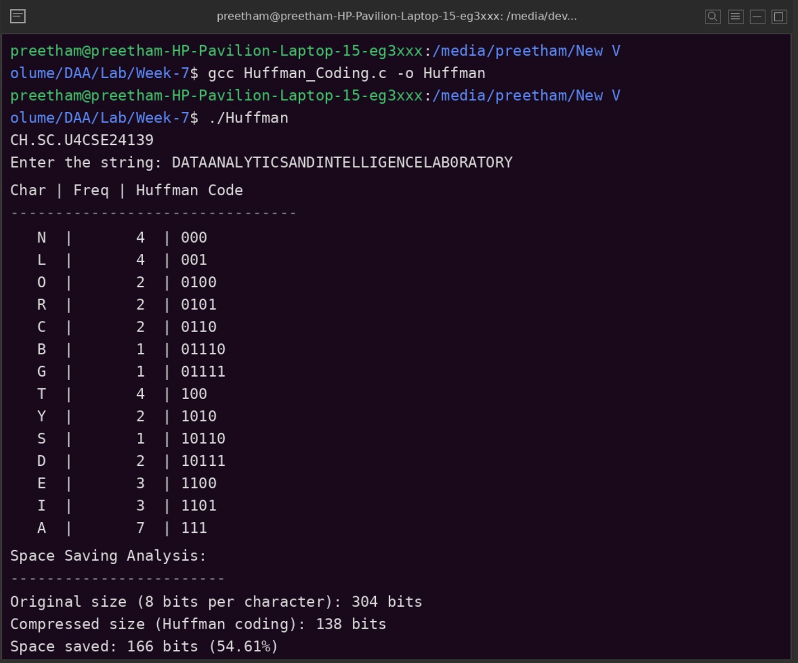

Time Complexity: O(n log n)
Justification: The algorithm builds a min-heap in O(n) time. It then performs n-1 iterations to extract the two smallest nodes and insert a new internal node. Each heap operation (insertion and extraction) takes O(log n) time, making the total construction time O(n log n). Tree traversal for printing codes is linear, O(n).
Space Complexity: O(n)
Justification: The space is primarily determined by the Huffman tree and the min-heap, both of which store O(n) nodes. Additionally, the recursion stack for generating codes depends on the tree height, which is O(n) in the worst-case (highly skewed tree) and O(log n) in the average case. No other significant auxiliary structures are used.

